Download file: <https://www.dropbox.com/s/poa32jx9ql7i5kd/test1.zip?dl=0>

Unzip into a new folder.

Find out port number:

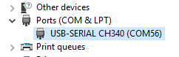

Edit file *_ESP32 write flash.cmd* with notepad and change port number.

Run Termite.exe, go to Settings, select port and set 115200, 8, N, 1. OK.

Click on large COM xxxx button to switch to Disconnected mode.

Run file *_ESP32 write flash.cmd*.

Before loading is finished click on large Disconnected button in Termite to switch into Waiting mode.

After loading is complete you should see a screen like this:

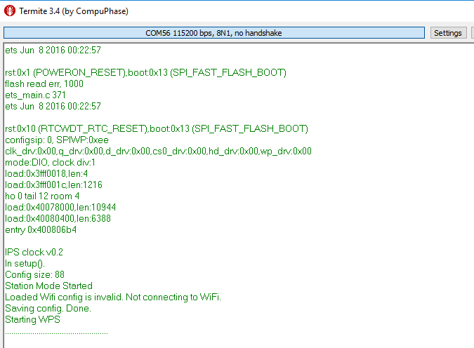

Press WPS button on your WiFi router (or start WPS Push-Button mode in your router’s web interface).

Clock will connect to internet and start up.

Log all the data on startup.